**Year 8 Geology Mid Topic Test 2013**

Name:_________________________ Mark: /47

**Multiple choice answer grid**

**1** A B C D

**2** A B C D

**3** A B C D

**4** A B C D

**5** A B C D

**6** A B C D

**7** A B C D

**8** A B C D

**9** A B C D

**10** A B C D

**11** A B C D

**12** A B C D

**13** A B C D

**14** A B C D

**15** A B C D

**16** A B C D

**17** A B C D

**18** A B C D

**19** A B C D

1. Granite is a rock that consists of crystals formed:

A by evaporation of liquid from a solution.

B from molten material from the mantle or lower crust as it cooled.

C by heat and pressure acting on rocks.

D by extremely rapid cooling of igneous material at the surface.

2. Igneous rocks can be:

A made of rounded grains cemented together.

B left behind when a solution evaporates.

C formed from eroded sediment.

D made of interlocking crystals.

3. Rock that forms from the cementing of deposited particles is called:

A metamorphic rock.

B igneous rock.

C sedimentary rock.

D volcanic rock.

4. A metamorphic rock is formed by the:

A slow cooling of molten magma to form large crystals.

B deposition and cementing of eroded particles.

C rapid cooling of molten magma to form crystals.

D effects of great heat and pressure on rock.

5. Gabbro is a dark-coloured intrusive igneous rock. A reasonable prediction is that:

A crystals in gabbro are difficult to see.

B all the crystals squashed into lines.

C the crystals are quite large.

D the rock has many holes in it.

6. The two most common processes that change a pile of sediment into a sedimentary rock are:

A compaction and cementation.

B weathering and erosion.

C deposition and sedimentation.

D cooling and crystallisation.

7. The first type of rock to form in the Earth’s crust was most likely:

A sedimentary.

B metamorphic.

C igneous.

D clastic sedimentary.

8. The water holding capacity of soils will be greater if:

A there is a lot of clay in the soil.

B there are large pore spaces in the soil.

C there are large crumbs.

D the soil contains a lot of sand.

9. The structure of a soil refers to:

A the size of the particles.

B how well the soil particles join up into crumbs.

C how fast water enters the soil.

D the tendency of soil particles to stick together.

10. Coal is a sedimentary rock that forms when:

A plants fall into lava and become burned to a black charcoal.

B bacteria in soil partially decompose and leave behind a black residue.

C tiny ancient single celled organisms became buried under soil that turned into rock.

D plants are buried and compressed between rock layers.

11. Basalt is formed when lava cools. What type of rock is it?

A Intrusive Igneous Rock

B Extrusive Igneous Rock

C Metamorphic

D Sedimentary

12. Magma and lava

A Are both types of rock

B Are both minerals

C Are both forms of molten rock

D Are exactly the same thing

13. Marble is a rock that is commonly used as a bench top as it is very hard and not porous. Which type of rock is marble?

A Intrusive Igneous Rock

B Extrusive Igneous Rock

C Metamorphic

D Sedimentary

14. Water entering cracks in the rock then expanding when the temperature goes below 0oC is an example of

A Erosion

B Physical Weathering

C Chemical Weathering

D Sedimentation

15. Particles being deposited at the bottom of a stream is an example of

A Erosion

B Physical Weathering

C Weathering

D Sedimentation

16. A piece of rock was caught in ice at the beginning of winter. As spring came and the ice thawed the piece of rock travelled down the hill with the melting ice. This is an example of:

A Erosion

B Physical Weathering

C Chemical Weathering

D Sedimentation

17. What most commonly leads to the formation of metamorphic rocks?

A Erosion

B Weathering

C Movement of tectonic plates

D Volcanic eruptions

18. Which of the following is **not** a form of physical weathering?

A Acid rain

B Glacier action

C Tree roots

D Ice in the cracks of rocks

19. Which of the following is correct about soil?

A Soil contains organic matter

B Sediment is the basic component of soil

C Soil contains living organisms

D All of the above are correct

**Short Answer**

1. Explain how the three different types of sedimentary rocks are formed. (3)

Clastic:_______________________________________________________________________________________________________________________________________________________________________________________________________________________________________________

Organic:__________________________________________________________________________________________________________________________________________________________________________________________________________________________________________

Chemical:___________________________________________________________________________________________________________________________________________________________________________________________________________________________________________

2. The following are a list of different rocks that have properties as described. Identify them as igneous, sedimentary or metamorphic. (6)

|  |  |
| --- | --- |
| Type of Rock | Description |
|  | shale: strongly layered and fragile, splitting into flat sheets of soft fine particles |
|  | basalt: very hard rock of small dark crystals |
|  | breccia: large sharp angled particles cemented by many fine rounded particles |
|  | limestone: soft rock with very small rounded white coloured grains including fossil shells found in an ocean reef |
|  | granite: very hard rock of large crystals of three different colours, white, light grey and black |
|  | gneiss: wavy dark lines set in light coloured rock, the elongated crystals are all lined up parallel to each other |

3. Complete the missing labels (numbered 1 to 4) on the diagram of the rock cycle below. (4)

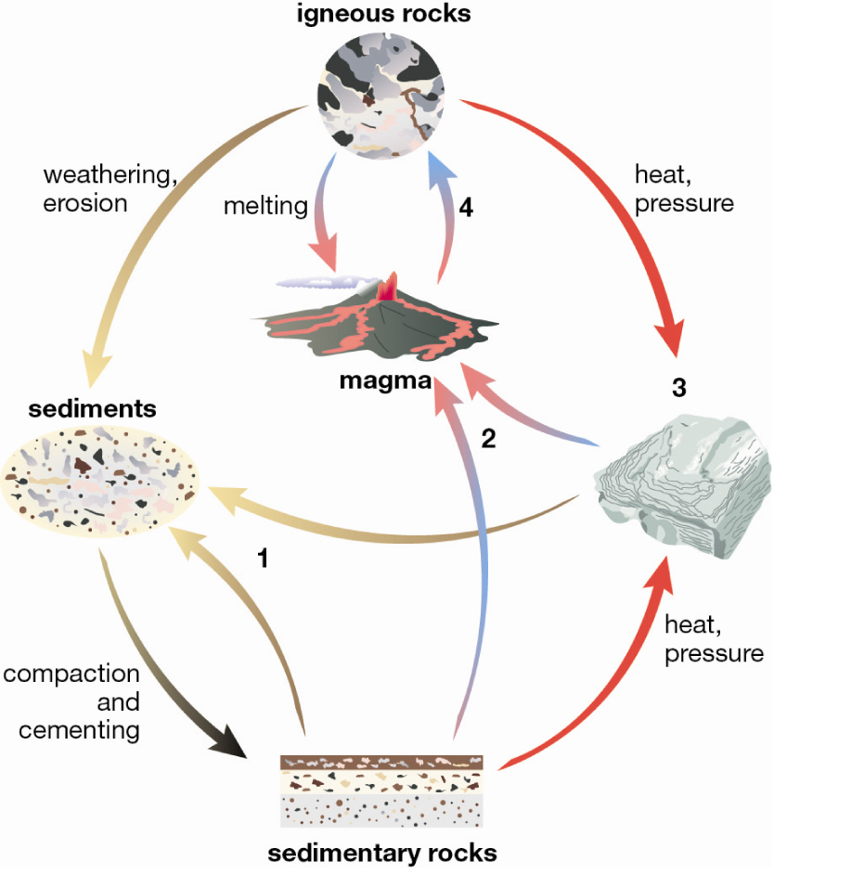

[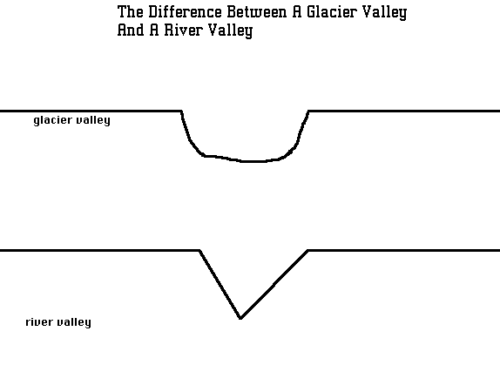](http://www.google.com.au/url?sa=i&rct=j&q=valley+formed+by+a+glacier&source=images&cd=&docid=iRL9FC0FY-g76M&tbnid=m2XY4Mfi1VlQPM:&ved=0CAUQjRw&url=http://library.thinkquest.org/3876/glaciers.html&ei=6sZgUtjqOo_OkgWFu4HACg&psig=AFQjCNFV1Hph0jm35VnR7xeEcugZjNWxnQ&ust=1382160467951082)4. The diagram below shows two valleys, one formed by a glacier and the other by a river. Which is which? (1)

5. Use the sedimentary rock classification key below to answer these questions.

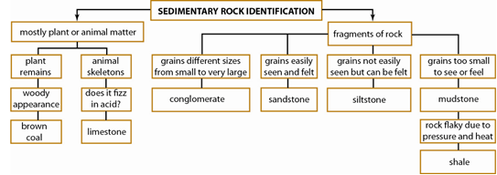

a Using the information in the key, describe limestone. (1)

______________________________________________________________________________________________________________________________________________________________________________________________________________________________________________________

b Compare siltstone and conglomerate. (1)

____________________________________________________________________________________________________________________________________________________________________

c Grace found a rock with grains in it that were easily visible and of roughly the same size (0.5 mm). Identify this rock. (1)

__________________________________________________________________________________

d Nick found a rock that he recognised as a mudstone, and it had abundant fossil shells in it. Assess the limitations of (problems with) this key in light of Nick’s discovery. (2)

_____________________________________________________________________________________________________________________________________________________________________________________________________________________________________________________

6. Explain why crystal size in igneous rocks is affected by how fast the rock cools. (2)

______________________________________________________________________________________________________________________________________________________________________________________________________________________________________________________

7. Pania and Taye collected sediment from four different places along the course of a river. They made a sketch map of the river with the sampling locations, and they labelled the bottles of sediment. Identify which sediment samples match which location, and explain your four choices. (8)

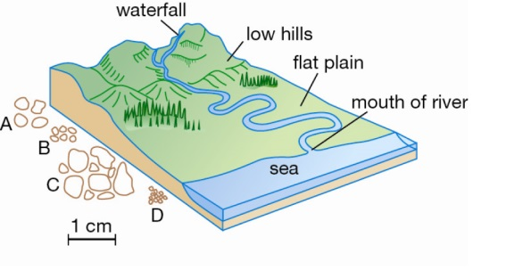

|  |  |  |
| --- | --- | --- |
| Sample | Location | Reason |
| A |  |  |
| B |  |  |
| C |  |  |
| D |  |  |

**Year 8 Geology Mid Topic SOLUTIONS**

Name:_________________________ Mark: /47

**Multiple choice answer grid**

**1** A B C D

**2** A B C D

**3** A B C D

**4** A B C D

**5** A B C D

**6** A B C D

**7** A B C D

**8** A B C D

**9** A B C D

**10** A B C D

**11** A B C D

**12** A B C D

**13** A B C D

**14** A B C D

**15** A B C D

**16** A B C D

**17** A B C D

**18** A B C D

**19** A B C D

**Short Answer**

1. Explain how the three different types of sedimentary rocks are formed. (3)

Clastic:___Weathered and eroded materials are deposited in layers and cemented together

Organic:Made from the remains of organisms accumulating and being cemented together

Chemical:When dissolved materials come out of solution, sink and are cemented together.

2. The following are a list of different rocks that have properties as described. Identify them as igneous, sedimentary or metamorphic. (6)

|  |  |
| --- | --- |
| Type of Rock | Description |
| Sedimentary | shale: strongly layered and fragile, splitting into flat sheets of soft fine particles |
| Igneous | basalt: very hard rock of small dark crystals |
| Sedimentary | breccia: large sharp angled particles cemented by many fine rounded particles |
| Sedimentary | limestone: soft rock with very small rounded white coloured grains including fossil shells found in an ocean reef |
| Igneous | granite: very hard rock of large crystals of three different colours, white, light grey and black |
| Metamorphic | gneiss: wavy dark lines set in light coloured rock, the elongated crystals are all lined up parallel to each other |

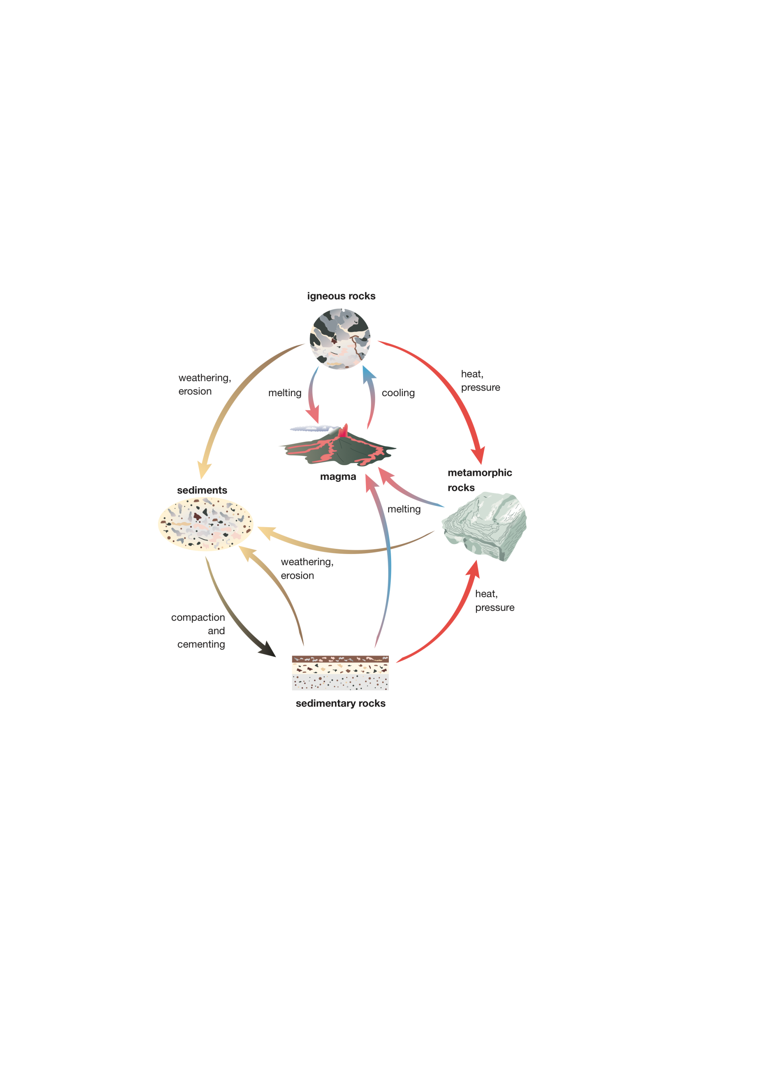3. Complete the missing labels (numbered 1 to 4) on the diagram of the rock cycle below. (4)

4. The diagram below shows two valleys, one formed by a glacier and the other by a river. Which is which? (1)

[](http://www.google.com.au/url?sa=i&rct=j&q=valley+formed+by+a+glacier&source=images&cd=&docid=iRL9FC0FY-g76M&tbnid=m2XY4Mfi1VlQPM:&ved=0CAUQjRw&url=http://library.thinkquest.org/3876/glaciers.html&ei=6sZgUtjqOo_OkgWFu4HACg&psig=AFQjCNFV1Hph0jm35VnR7xeEcugZjNWxnQ&ust=1382160467951082)

Glacier

River

5. Use the sedimentary rock classification key below to answer these questions.



a Using the information in the key, describe limestone. (1)

Limestone is described in this key as a rock that consists mostly of animal skeletons and fizzes in acid.

b Compare siltstone and conglomerate. (1)

The grains in siltstone are smaller than those that make up conglomerate.

c Grace found a rock with grains in it that were easily visible and of roughly the same size (0.5 mm). Identify this rock. (1)

sandstone

d Nick found a rock that he recognised as a mudstone, and it had abundant fossil shells in it. Assess the limitations of (problems with) this key in light of Nick’s discovery. (2)

The key would not correctly identify the rock as it has features of both limestone and mudstone.

6. Explain why crystal size in igneous rocks is affected by how fast the rock cools. (2)

Slow cooling (over millions of years) produces large crystals because the particles can move around and keep adding to a nearby crystal, which then continues to grow bigger.

Fast cooling (in days or years) does not allow particles enough time to move to large crystals growing nearby and add to these. Instead, they form lots of tiny crystals. Some form no obvious crystals.

7. Pania and Taye collected sediment from four different places along the course of a river. They made a sketch map of the river with the sampling locations, and they labelled the bottles of sediment. Identify which sediment samples match which location, and explain your four choices. (8)



|  |  |  |
| --- | --- | --- |
| Sample | Location | Reason |
| A | from the low hills | . The grains are still large, but are rounded from travelling. |
| B | Winding part of the river on the flat plain | The grains have been worn small and very rounded from constant rolling in the water. |
| C | Mountain waterfall | The sediment has large pieces consistent with a high-energy environment, and they have not yet travelled far enough after being smashed to be rounded. |
| D | Mouth of the river | The water has become quieter and quieter and only fine grains are being transported now. |